Numinous Health
Confidential Intake Form

Date:
*Please note: Any information provided on these forms are kept strictly confidential.
Patient Information

Name: Gender:
Age: Date of Birth:
Home Address:

Home Phone: Cell: Work Phone:
Email:

Emergency Contact: Relationship to Patient:
Emergency Contact Phone number:
Primary Care Physician (PCP): PCP Phone:
Date of last medical examination:
Occupation:

- Experience
Have you received acupuncture treatment before? YES NO

If yes, for what conditions and what was the outcome?

- Complaint
What would you like treated by Acupuncture?

How and when did this condition develop?

Was the onset: SUDDEN GRADUAL
Symptoms are worsened by:

Symptoms are better by:

Medical diagnosis received, if any:

What other treatments are you doing/have you done to manage your condition?

How does this condition affect your daily activities?

On the diagram, please shade in the areas that you feel need to be addressed:
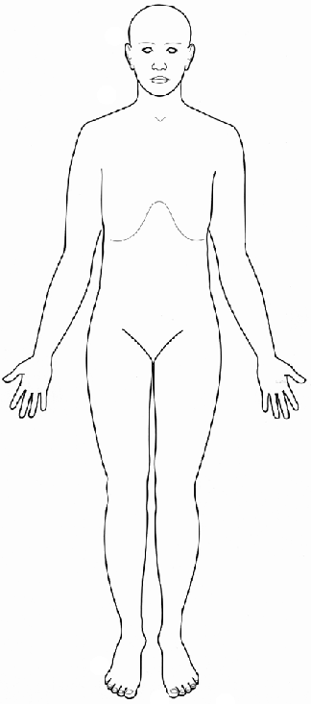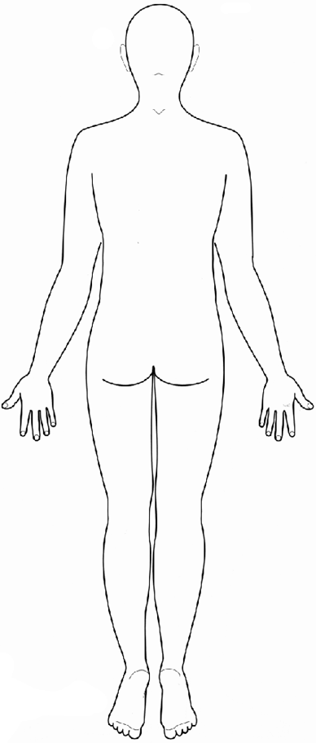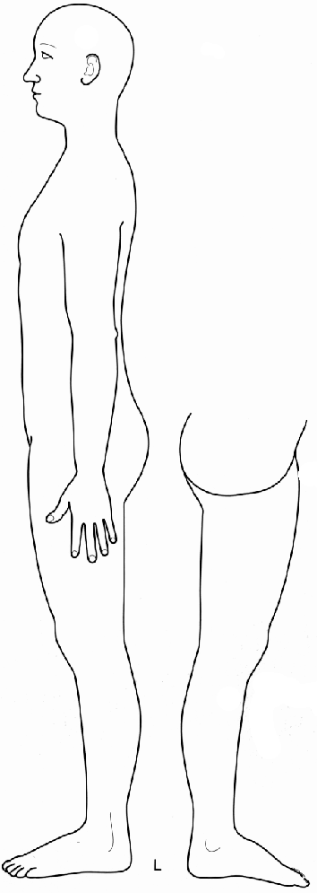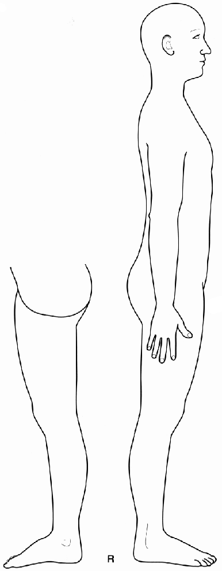

- Medications, Supplements and herbs
Please list ALL medications, (prescriptions & OTC drugs) supplements and herbs you are taking, even if taking occasionally:

Medications, supplements, or herbs: Indication/For treatment of:
1. 1.
2. 2.
3. 3.
4. 4.
5. 5.
6. 6.
7. 7.
8. 8.
9. 9.
10. 10.

  - List any allergies:

- Personal Medical History

Birth: Describe anything significant/traumatic about your birth:

Vaccination History: Any unusual reaction? Any unusual vaccination?

Childhood Illnesses (0-12 years): Any surgery, accidents & /or major illnesses? Please list in chronological order and indicate duration of illnesses.
Age:
Age:
Adolescence Illnesses (13-17 years): Any surgery, accidents & /or major illnesses? Please list in chronological order and indicate duration of illnesses.
Age:
Age:
Adulthood Illnesses (18 – 35 years): Any surgery, accidents & /or major illnesses? Please list in chronological order and indicate duration of illnesses.
Age:
Age:
Adulthood Illnesses (36 & up): Any surgery, accidents & /or major illnesses? Please list in chronological order and indicate duration of illnesses.
Age:
Age:

- Family Medical History
Please note all major illnesses in your close family, e.g. diabetes, heart disease, hypertension, neurological disorders, psychological disorders, blood disorders, cancer, high cholesterol, etc.

Mother
Father
Siblings
Maternal Grandparents
Paternal Grandparents

- Symptom Overview BY System
Please CIRCLE all symptoms that you are CURRENTLY experiencing AND/OR experience FREQUENTLY. UNDERLINE symptoms that have affected you BEFORE, but within the last year.

Musculoskeletal
Joint clicking Limitation of movement Stiffness
Spasms or cramps Swelling Weakness
Pain:
Full body Facial (e.g. jaw) Neck Upper Back
Mid Back Low Back Shoulder Elbow Wrist
Hand Hip Knee Ankle Foot
OTHER (Please list)

Pain is:
Sharp Achey Numb Deep Burning Dull
Superficial Tingling
Better: Heat Cold Movement AM PM
Worse: Heat Cold Movement AM PM
Eyes, Ears, Nose, Throat, Respiratory
Loss of vision Eye pain Tearing or eye dryness
Eye discharge Eye redness Floaters (seeing spots)
Ear discharge Ear itchng Ear pain &/or infections
Loss of hearing Ringing/buzzing in ears
Problems w/ balance (vertigo)
Olfaction (sense of smell) impaired
Nose obstruction (stuffiness) Nose bleeds
Sinus pain, pressure &/or infections Frequent colds
Smoke? Yes No per day, for years
Chest pain &/or tightness Bluish discoloration of skin
Cough Coughing up blood (hemoptysis)
Shortness of breath (dypsnea) Sore throat
Sputum production Voice changes Wheezing
Phlegm/mucus Color?
OTHER (Please list)

Cardiovascular
Blood pressure /
Changes in skin temperature & color
Chest pain &/or pressure Edema Fainting (syncope)
Fatigue Palpitations Skin ulceration
Swelling of the ankles &/or legs
OTHER (Please list)

Digestive
Abdominal distention/bloating Abdominal mass
Abdominal pain Acid regurgitation &/or Heartburn
Alternating constipation/diarrhea Rectal bleeding
Constipation Diarrhea Gas Eating disorder
Indigestion Jaundice (yellow tint to skin &/or eyes)
Nausea Vomiting
OTHER (Please list)

Bowel movements: times a day/week
Painful? Yes No
Irregular Burning Undigested food in stool
Loose stool Hard stool “Rabbit” stool
Blood in stool Itchiness
Urogenital
Difficulty with urine flow Incontinence
Painful urination (dysurea) Rashes Red urine
Urinary tract infection (UTI)
How often? Times
Color: Clear Pale yellow Dark yellow/orange
OTHER (Please list)

Neurological
Changes in consciousness Confusion Dizziness
Difficulty concentrating Paralysis Post shingles pain
Dysphasia (impaired ability to speak) Gait disturbance
Numbness and/or tingling Loss of consciousness
Problems coordinating movements Severe forgetfulness
Tremor Visual disturbance Weakness
OTHER (Please list)

Integumentary (Skin)
Changes in hair Changes in nails Unusual sweating
Changes in skin color Itching (prurites) Never sweat
Rash and/or skin lesion Wounds that will NOT heal
Night sweats
OTHER (Please list)

Psychological
Feelings of grief Feelings of sadness Feeling manic
Feeling fearful/anxious/nervous Feeling irritable
Difficulty managing anger Extreme lack of emotion
Feeling worried or overly pensive Panic attacks
Feeling overwhelmed Extreme mood swings
Poor memory Difficulty concentrating
OTHER (Please list)

Are you: Married/Stable relationship Single
How do you feel about your relationship?

How do you hold stress?

If you hold stress in your body, where?

How do you feel about your work?

How do you relax?

Sleep
Difficulty falling asleep Dream disturbed sleep
Wake up & cannot fall back asleep
At what time(s) do you wake up & cannot fall back to
sleep?
How many hours do you sleep?
OTHER (Please list)

WOMEN

Abnormal vaginal bleeding Changes in hair distribution
Fertility concerns Irregular menstruation
Menopausal symptoms No menses
Pain with menses (dysmenorrhea) Unusual discharge
Pain during or after sexual relations Pelvic pain
Premenstrual (PMS) symptoms Sexual dysfunction
What type of birth control do you use?
How is your libido? High Low Normal
OTHER (Please list)

- Are you currently pregnant? YES NO
- Are you presently trying to get pregnant? YES NO

Have you ever been pregnant? YES NO If yes, how many pregnancies:
# Births
# Miscarriages
# Abortions
MEN

Fertility concerns Prostate problems
Sexual dysfunction Unusual discharge
How is your libido? High Low Normal
OTHER (Please list)

- MEDICAL DISEASES/CONDITIONS
Please CIRCLE current conditions and UNDERLINE past/resolved conditions.

AIDS/HIV Alcoholism &/or substance addiction
Allergies (If yes, pls indicate diagnosis & history)

Anemia Asthma Bell’s Palsy
Blood clotting disorder (If yes, pls indicate diagnosis & history)

Bipolar disorder
Cancer (If yes, pls indicate diagnosis & history)

Chron’s Disease &/or colitis Infertility
Chronic Fatigue Syndrome(CFIDS) Depression (Major)
Diabetes Eczema Endometriosis Fibroids
Lung disease(ex.COPD)(If yes, pls indicate diagnosis &history)

Fibromyalgia Gallstones
Heart disease (If yes, pls indicate diagnosis & history)

Hepatitis A / B / C Hernia Herpes
Hypertension Hypoglycemia
Irritable Bowel Syndrome (IBS)
Joint Replacement (If yes, pls indicate diagnosis & history)

Kidney Stones and/or Disease (If yes, pls indicate diagnosis & history)

Lupus Lyme Disease Lymph node removal
Mitral valve prolapse Mood Disorder Mononucleosis Multiple Sclerosis
Organ removal or transplant (If yes, pls indicate diagnosis & history)

Osteoarthritis Osteoporosis
Pacemaker (heart or stomach) Parkinson’s Disease
Pelvic Inflammatory Disease Polio Psoriasis
PTSD (Post-Traumatic Stress Disorder)
Reflux esophagistis (GERD) Rheumatic fever
Rheumatoid arthritis Scarlet Fever Schizophrenia
Scoliosis Seizures and /or epilepsy Shingles
Sleep Disorder Stroke Schizophrenia
Thyroid disease (If yes, pls indicate diagnosis & history)

Ulcer Trigeminal Neuralgia Tuberculosis
Vascular disease (e.g. phlebitis) (If yes, pls indicate diagnosis & history)

OTHER (pls list)

- Lifestyle Information

- Diet & Nutrition
How is your apetite? Good Poor No appetite Hungry all the time
Food cravings:
Food allergies/intolerances:
History of: Anorexia Bulimia Meals per day:
How often do you have: Meat day/week Vegetables day/week Dairy day/week
Caffeine (Coffee, Tea) day/week Sugar/Sweets day/week
Rate your preferences 1-5 (1=dislike most, 5=like most)
Salty Sweet Bitter Sour Spicy
Are you always thirsty? Yes No How do you prefer your drinks? Hot Cold
Alcohol consumption: drinks per: day/week

- Exercise & Energy Level
Do you exercise? Yes No
How often? times a week
What type of exercises do you do?
How is your energy? Low High Fluctuates
What time(s) of the day is your energy: High Low

